

**RESTAURANT WEBSITE**



|  |  |
| --- | --- |
| **Supervised By:**  RAVEESH SAMKARIA | **Submitted By:**  Uday Aggarwal  2210990917 (G-14) |



# ABSTRACT

L’Gran invites you to embark on a culinary journey that celebrates the essence of flavor and creativity. Our restaurant blends contemporary elegance with warm hospitality to offer an unforgettable dining experience.

Our menu is a symphony of tastes inspired by global cuisines, meticulously crafted by our talented chefs using locally sourced, fresh ingredients. From succulent steaks to vibrant vegetarian delights, there's something to tantalize every palate.

At L’Gran, we pride ourselves on delivering exceptional service, ensuring each guest feels welcomed and valued. Whether you're joining us for a romantic dinner, a family celebration, or a casual gathering with friends, our dedicated team is committed to making your experience memorable.

# INTRODUCTION

Welcome to the culinary haven where every bite is a journey and every meal is an experience – Welcome to L’Gran.

Step into a world where passion meets flavor, where creativity dances on your taste buds, and where every dish tells a story. Our restaurant is more than just a place to eat; it's a destination where memories are made, and palates are delighted.

From the moment you walk through our doors, you'll be greeted with warmth and hospitality, as our team works tirelessly to ensure your satisfaction.

Our menu is a testament to our commitment to excellence, featuring a curated selection of dishes that celebrate the diversity of culinary traditions from around the world. Each ingredient is carefully chosen for its quality and freshness, ensuring that every bite is a moment of pure bliss.

Join us on a gastronomic journey unlike any other, and discover why we're more than just a restaurant – we're an experience to remember.

# OBJECTIVE

Our restaurant website aims to provide a seamless and engaging platform for visitors to explore our culinary offerings, learn about our ethos and commitment to quality, and ultimately, to inspire them to dine with us. Through intuitive design, mouthwatering visuals, and informative content, we strive to create an online experience that mirrors the warmth and hospitality of our physical establishment. Our goal is to establish a strong online presence, attract new patrons, and cultivate a loyal community of food enthusiasts who appreciate the artistry and passion behind every dish we serve.

# SIGNIFICANCE

**Digital Storefront:**

Serves as the online representation of the restaurant, acting as a digital storefront accessible 24/7.

Allows potential customers to explore the restaurant's offerings, ambiance, and menu from the comfort of their own homes.

**Information Hub:**

Provides essential details such as location, contact information, operating hours, and reservation options, facilitating easy access for customers.

Offers insight into the restaurant's history, ethos, and values, helping to establish a connection with visitors.

**Brand Identity and Image:**

Reflects the unique personality and style of the restaurant through design elements, color schemes, and branding. Conveys professionalism, credibility, and attention to detail, shaping visitors' perception of the restaurant.

**Marketing and Promotion:**

Serves as a powerful marketing tool, allowing the restaurant to showcase its signature dishes, promotions, and events.

Integrates with social media platforms to expand reach, engage with customers, and drive traffic to the website.

**Customer Engagement:**

Facilitates direct communication with customers through features such as online reservations, contact forms, and newsletters.

Provides opportunities for feedback and reviews, enabling the restaurant to gather insights and improve the overall dining experience.

**Accessibility and Convenience:**

Enhances accessibility for customers with disabilities through features such as screen reader compatibility and alternative text for images.

Offers convenient online ordering and delivery options, catering to customers who prefer to dine at home.

**Competitive Advantage:**

Sets the restaurant apart from competitors by offering a professional and user-friendly online experience. Helps the restaurant stay relevant in a digital-driven marketplace and attract tech-savvy customers.

**Analytics and Insights:**

Utilizes web analytics tools to track visitor behavior, monitor website performance, and identify areas for improvement.

Provides valuable insights into customer preferences, popular menu items, and marketing effectiveness.

**PROBLEM STATEMENT**

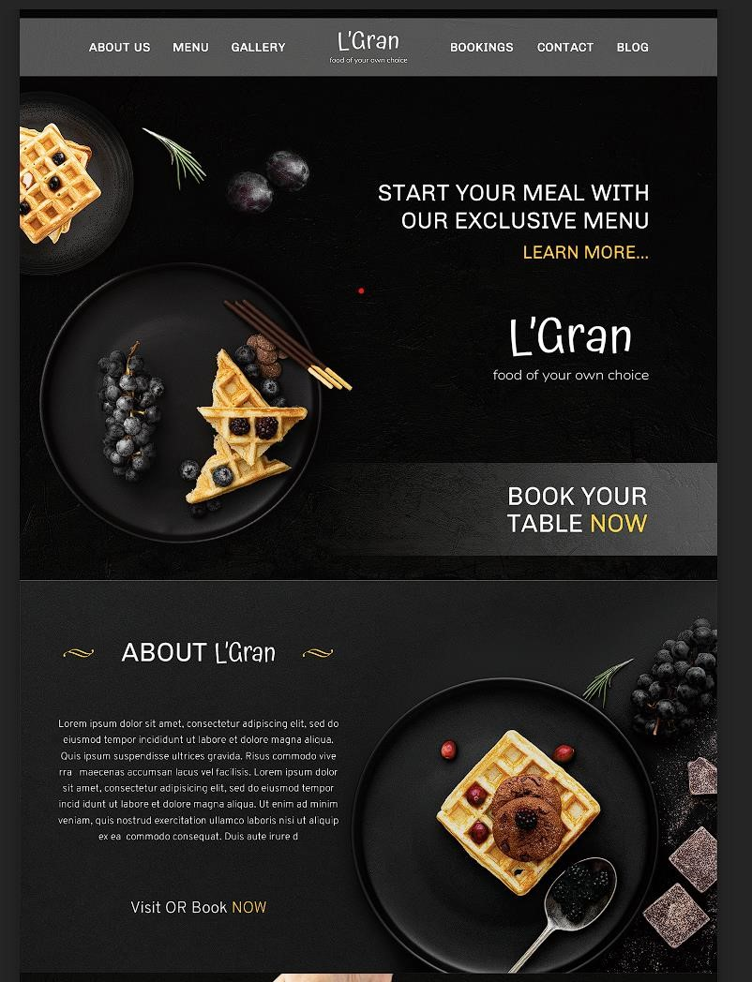We were provided with the unique templates to design them in same way. Below is the screenshot of template provided to me.

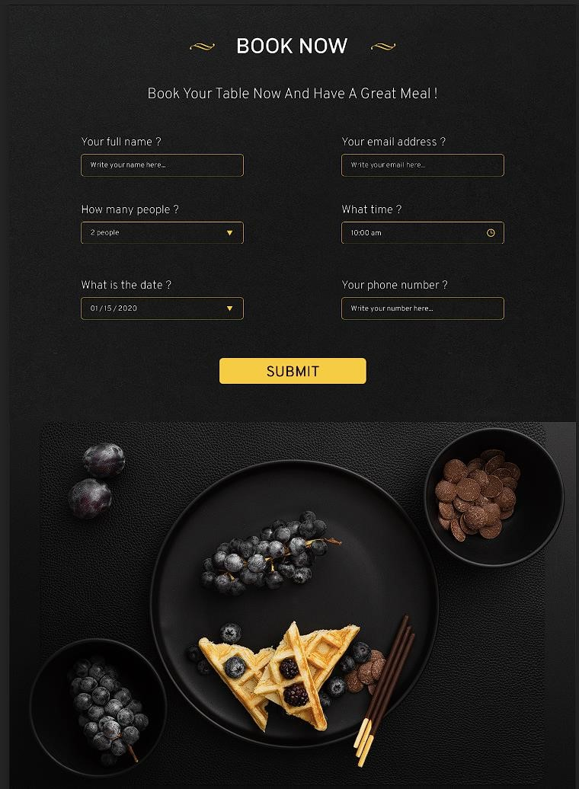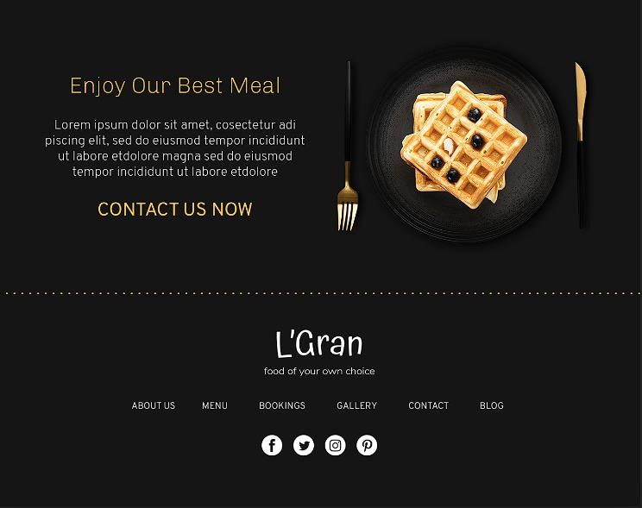

# REQUIREMENTS

***Software Requirements:***

**HTML**: HTML provides the fundamental structure for web pages, consisting of elements enclosed in tags, which define the content and layout.

HTML documents should adhere to standards and undergo validation to ensure proper syntax, structure, and compatibility across different web browsers and device

**CSS**: CSS is used to define the presentation and layout of HTML elements on a web page, including aspects such as color, font, size, spacing, and positioning. CSS models elements on a web page as rectangular boxes, comprising content, padding, border, and margin. Developers can manipulate these box properties to control layout and spacing.

# PROJECT DESIGN

* **Project Overview**

Design and develop a dynamic restaurant website for “L’Gran" focusing on showcasing its ambiance, menu, and reservation options, with responsive design, SEO optimization, and ongoing maintenance.

* **File Structure**

The project will utilize a well-organized folder structure for efficient management and future updates.

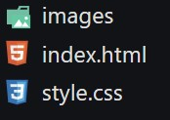**index.html:** Main HTML file containing the overall website structure and content

**style.css:** Primary CSS file for styling all website elements.

**images:** Folder containing all images used on the website.

# METHODOLOGY

***HTML CODE:***

<!DOCTYPE html>

<html lang="en">

  <head>

    <meta charset="UTF-8" />

    <meta name="viewport" content="width=device-width, initial-scale=1.0" />

    <script

      src="https://kit.fontawesome.com/c403aeab91.js"

      crossorigin="anonymous"

    ></script>

    <title>LGran</title>

    <link rel="stylesheet" href="./style.css" />

    <link rel="shortcut icon" href="./images/imagesgallery.png" type="image/x-icon">

  </head>

  <body>

    <section class="hero">

      <div class="innerHero">

        <div class="ForBg">

          <ul class="Nav">

            <li class="ListIn">

              <ul class="innerList">

                <li class="textList">About Us</li>

                <li class="textList">Menu</li>

                <li class="textList">Gallery</li>

              </ul>

            </li>

            <li><img src="./images/logo.png" alt="" /></li>

            <li class="ListIn">

              <ul class="innerList">

                <li class="textList">bookings</li>

                <li class="textList">Contact</li>

                <li class="textList">Blog</li>

              </ul>

            </li>

            <li class="hidden hamLi">

              <div class="ham" id="ham">

                <i class="fas fa-bars hamburger"></i>

              </div>

            </li>

          </ul>

          <div class="heroContent">

            <div class="TextHero">

              <p class="con">

                Start Your Meal With <br />

                Our Exclusive Menu

              </p>

              <p class="Gold">Learn More....</p>

            </div>

            <div class="logo bluronsmall">

              <img src="./images/logo.png" class="logoimgHero" />

            </div>

            <div class="Booking">

              <p>

                Book Your <br />

                Table <span class="now">Now</span>

              </p>

            </div>

          </div>

        </div>

      </div>

    </section>

    <section class="part2">

      <div class="innerpart2">

        <div class="contentpart2">

          <div class="HeadingStyled">

            <div class="tata">

              <img src="./images/Tatat.png" alt="" />

            </div>

            <p class="about">ABOUT <span class="spec">L'Gran</span></p>

            <div class="tata">

              <img src="./images/Tatat.png" alt="" />

            </div>

          </div>

          <div class="content">

            <p>

              Lorem ipsum dolor sit amet, consectetur adipiscing elit, sed do

              eiusmod tempor incididunt ut labore et dolore magna aliqua. Quis

              ipsum suspendisse ultrices gravida. Risus commodo vive rra

              maecenas accumsan lacus vel facilisis. Lorem ipsum dolor sit amet,

              consectetur adipisicing elit, sed do eiusmod tempor incid idunt ut

              labore et dolore magna aliqua. Ut enim ad minim veniam, quis

              nostrud exercitation ullamco laboris nisi ut aliquip ex ea commodo

              consequat. Duis aute irure d

            </p>

          </div>

          <div class="visi">

            <p class="goldupper">

              Visit or Book <span class="Gold2">Now</span>

            </p>

          </div>

        </div>

      </div>

    </section>

    <section class="part3">

      <div class="innerpart3">

        <div class="forbgagain">

          <div class="contentforpart3">

            <div class="headingAgainStyled">

              <div class="tata">

                <img src="./images/tatatwhite.png" alt="" />

              </div>

              <p class="about2">Our Food Quality</p>

              <div class="tata">

                <img src="./images/tatatwhite.png" alt="" />

              </div>

            </div>

            <div class="contentdiv3">

              <p>

                Lorem ipsum dolor sit amet, consectetur adipiscing elit, sed do

                <br />

                eiusmod tempor incididunt ut labore et dolore magna aliqua. Quis

                <br />

                ipsum suspendisse ultrices gravida.

              </p>

            </div>

            <div class="visi">

              <p class="goldupper2">

                <span class="ooo1">Double The Fun</span> <br />On Every Saturday

                <br />

                <span class="Gold21">Get upto 50% discount</span>

              </p>

            </div>

          </div>

        </div>

      </div>

    </section>

    <section class="part4">

      <div class="innerpart4">

        <div class="headingpart4">

          <div class="tata">

            <img src="./images/Tatat.png" alt="" />

          </div>

          <p class="about">Gallery</p>

          <div class="tata">

            <img src="./images/Tatat.png" alt="" />

          </div>

        </div>

        <div class="images"></div>

      </div>

    </section>

    <section class="part5">

      <div class="innerpart5">

        <div class="BookNow">

          <div class="headingpart5">

            <div class="tata">

              <img src="./images/Tatat.png" alt="" />

            </div>

            <p class="about">Book Now</p>

            <div class="tata">

              <img src="./images/Tatat.png" alt="" />

            </div>

          </div>

        </div>

        <div class="Tagline">

          <p>Book Your Table Now And Have A Great Meal !</p>

        </div>

        <form class="Form">

          <label for="fulln" class="formele" id="fullname"

            >Your Full Name?<input placeholder="Full Name" type="text" name="fullname" id="fulln"

          /></label>

          <label for="Emaili" class="formele" id="Email"

            >Your Email?<input placeholder="Email" type="text" name="Email" id="Emaili"

          /></label>

          <label for="peoplef" class="formele" id="people"

            >How many People?<select name="People" id="peoplef">

              <option value="1">1</option>

              <option value="1">2</option>

              <option value="1">3</option>

              <option value="1">4</option>

              <option value="1">5</option>

            </select></label>

          <label for="TIme" class="formele" id="time"

            >What Time?<input placeholder="Time" type="time" name="fullname" id="TIme"

          /></label>

          <label for="date1" class="formele" id="date"

            >Date?<input type="date" name="date" id="date1"

          /></label>

          <label for="PhNum" class="formele" id="phoneNum"

            >Your Phone Number<input placeholder="Phone Number" type="text" name="Phone Number" id="PhNum"

          /></label>

        </form>

        <div class="Submit">

          <button class="SubmitButton">Submit</button>

        </div>

      </div>

    </section>

    <section class="part6">

      <div class="innerpart6"></div>

    </section>

    <section class="part7">

      <div class="innerpart7">

        <div class="part7Con">

          <p class="contt">Lorem ipsum dolor sit amet, consectetur adipisicing elit, sed do eiusmod tempor incidi- <br> dunt ut labore et dolore magna aliqua. Ut enim ad minim veniam, quis </p>

          <p class="Writer">Linda Steward</p>

        </div>

      </div>

    </section>

    <section class="part8">

      <div class="innerpart8">

        <div class="mealcont">

          <h1>Enjoy Our Best Meal</h1>

          <p>Lorem ipsum dolor sit amet, cosectetur adi <br>

            piscing elit, sed do eiusmod tempor incididunt <br> ut labore etdolore magna sed do eiusmod <br> tempor incididunt ut labore etdolore</p>

            <p class="COntect">Contact Us Now</p>

        </div>

      </div>

    </section>

    <footer class="footer">

      <div class="innerFooterContent">

        <div class="ContentFinalFooter">

          <img src="./images/logo.png" alt="">

          <ul class="footlinks">

            <li>About Us</li>

            <li>Menu</li>

            <li>Bookings</li>

            <li>Gallery</li>

            <li>Contact</li>

            <li>Blog</li>

          </ul>

          <ul class="contacts">

            <li><img src="./images/fb.png" alt=""></li>

            <li><img src="./images/twitter.png" alt=""></li>

            <li><img src="./images/insta.png" alt=""></li>

            <li><img src="./images/pinterest.png" alt=""></li>

          </ul>

        </div>

      </div>

    </footer>

  </body>

</html>

***CSS CODE:***

@import "https://fonts.googleapis.com/css2?family=Poppins:ital,wght@0,100;0,200;0,300;0,400;0,500;0,600;0,700;0,800;0,900;1,100;1,200;1,300;1,400;1,500;1,600;1,700;1,800;1,900&display=swap";

@import url("https://fonts.googleapis.com/css2?family=Atma:wght@300;400;500;600;700&display=swap");

@import url("https://fonts.googleapis.com/css2?family=Atma:wght@300;400;500;600;700&family=Overpass:ital,wght@0,100..900;1,100..900&display=swap");

* {

*margin*: 0;

*padding*: 0;

*box-sizing*: border-box;

*color*: white;

*font-family*: "poppins", sans-serif;

*list-style-type*: none;

}

img {

*cursor*: pointer;

}

body {

*background*: black;

*background-image*: url("./images/grainHEro.png");

*background-attachment*: fixed;

}

.hidden {

*display*: none;

}

.hero {

*height*: 100vh;

*width*: 100%;

*display*: flex;

*justify-content*: center;

*align-items*: center;

*overflow*: hidden;

}

.ListIn {

*width*: 100%;

}

.innerList {

*display*: flex;

*width*: 100%;

*justify-content*: space-evenly;

*align-items*: center;

}

.innerHero {

*height*: 100%;

*max-width*: 1440px;

*width*: 100%;

*background-image*: url("./images/grainHEro.png");

}

.ForBg {

*background-image*: url("./images/Hero.png");

*height*: 100%;

}

.Nav {

*padding-block*: 1.5%;

*height*: 12%;

*display*: flex;

*justify-content*: center;

*align-items*: center;

*list-style*: none;

*color*: white;

}

.textList {

*font-size*: 1.5rem;

*font-family*: "poppins", sans-serif;

*text-transform*: uppercase;

*cursor*: pointer;

*transition*: all 0.5s;

}

.textList:hover {

*text-decoration*: underline;

*transition*: all 0.5s;

}

.heroContent {

*display*: flex;

*flex-direction*: column;

*justify-content*: space-evenly;

*align-items*: end;

*height*: 88%;

*padding-inline*: 5%;

}

.TextHero {

*text-transform*: uppercase;

}

.con {

*font-size*: 44px;

*text-align*: end;

}

.Gold {

*color*: gold;

*font-size*: 36px;

*text-align*: end;

}

.logoimgHero {

*height*: 6rem;

}

.Booking > p {

*font-size*: 44px;

*text-transform*: uppercase;

}

.now {

*color*: gold;

}

.part2 {

*height*: 82vh;

*width*: 100%;

*display*: flex;

*justify-content*: center;

*align-items*: center;

}

.innerpart2 {

*max-width*: 1440px;

*background-repeat*: no-repeat;

*width*: 100%;

*height*: 100%;

*background-image*: url("./images/part2bg.png");

*padding-inline*: 5%;

*display*: flex;

*justify-content*: start;

*align-items*: center;

}

.HeadingStyled {

*display*: flex;

*justify-content*: space-between;

*width*: 100%;

  /* width: 50%; */

}

.spec {

*font-family*: "Atma", sans-serif;

}

.about {

*font-size*: 44px;

}

.contentpart2 {

  /* padding: 10%; */

*display*: flex;

*flex-direction*: column;

*align-items*: start;

*justify-content*: space-evenly;

*height*: 80%;

*width*: 40%;

}

.tata {

*display*: flex;

*align-items*: center;

*justify-content*: center;

}

.visi {

*font-size*: 44px;

*width*: 100%;

*font-weight*: 200;

*text-transform*: uppercase;

*display*: flex;

*justify-content*: center;

*align-items*: center;

*text-align*: center;

}

.goldupper {

*text-align*: center;

}

.Gold2 {

*color*: gold;

}

.part3 {

*height*: 82vh;

*width*: 100%;

*display*: flex;

*justify-content*: center;

*align-items*: center;

}

.innerpart3 {

*max-width*: 1440px;

*height*: 100%;

*width*: 100%;

*background-image*: url("./images/grainHEro.png");

}

.forbgagain {

*height*: 100%;

*width*: 100%;

*background-image*: url("./images/part3bg.png");

*background-repeat*: no-repeat;

*background-position*: left;

*padding-inline*: 5%;

*display*: flex;

*justify-content*: end;

*align-items*: center;

}

.contentforpart3 {

*height*: 60%;

*width*: 50%;

*display*: flex;

*flex-direction*: column;

*align-items*: center;

*justify-content*: space-between;

}

.headingAgainStyled {

*display*: flex;

*justify-content*: space-between;

*width*: 100%;

*text-transform*: uppercase;

}

.contentdiv3 {

*text-align*: center;

}

.goldupper2 {

*text-align*: center;

}

.ooo1 {

*font-size*: 53px;

*font-weight*: 300;

}

.Gold21 {

*color*: gold;

*font-size*: 28px;

}

.about2 {

*font-size*: 44px;

}

.part4 {

*height*: 130vh;

*width*: 100%;

*display*: flex;

*justify-content*: center;

*align-items*: center;

*padding-bottom*: 10vh;

}

.innerpart4 {

*max-width*: 1440px;

*display*: grid;

*grid-template-areas*:

    "heading"

    "heading"

    "images"

    "images"

    "images"

    "images"

    "images"

    "images"

    "images";

*height*: 100%;

*width*: 100%;

*background-image*: url("./images/grainHEro.png");

}

.headingpart4 {

*grid-area*: heading;

  /* display: grid ; */

  /* place-items: center; */

*display*: flex;

*justify-content*: center;

*align-items*: center;

*gap*: 4%;

*text-transform*: uppercase;

*font-weight*: 300;

}

.images {

*grid-area*: images;

*background-image*: url("./images/imagesgallery.png");

*background-repeat*: no-repeat;

*background-position*: center;

}

.part5 {

*height*: 100vh;

*width*: 100%;

*display*: flex;

*justify-content*: center;

*align-items*: center;

}

.innerpart5 {

*max-width*: 1440px;

*display*: grid;

*grid-template-areas*:

    "BookNow"

    "BookNow"

    "Tagline"

    "Form"

    "Form"

    "Form"

    "Form"

    "Form"

    "Form"

    "Form"

    "Submit";

*height*: 100%;

*width*: 100%;

*background-image*: url("./images/grain.png");

*background-repeat*: no-repeat;

}

.BookNow {

*grid-area*: BookNow;

*display*: flex;

*justify-content*: center;

*align-items*: center;

}

.Tagline {

*grid-area*: Tagline;

*display*: flex;

*justify-content*: center;

*align-items*: start;

}

.Tagline > p {

*font-family*: "Overpass", sans-serif;

*font-size*: 1.8rem;

*font-weight*: 200;

}

.Submit {

*display*: flex;

*justify-content*: center;

*align-items*: start;

}

.SubmitButton {

*font-size*: 1.5rem;

*padding-inline*: 7%;

*padding-block*: 0.5%;

*color*: black;

*border*: 2px solid black;

*background-color*: gold;

*border-radius*: 10px;

*text-transform*: uppercase;

*cursor*: pointer;

*transition*: all 0.5s;

}

.SubmitButton:hover {

*background-color*: rgb(182, 155, 1);

*transition*: all 0.5s;

}

.Form {

*grid-area*: Form;

*display*: grid;

*grid-template-areas*:

    "fullName email"

    "people time"

    "date phoneNum";

*padding-inline*: 15%;

}

#fullname {

*grid-area*: fullName;

}

#Email {

*grid-area*: email;

}

#people {

*grid-area*: people;

}

#time {

*grid-area*: time;

}

#date {

*grid-area*: date;

}

#phoneNum {

*grid-area*: phoneNum;

}

.Submit {

*grid-area*: Submit;

}

.headingpart5 {

*height*: 100%;

*display*: flex;

*justify-content*: center;

*align-items*: center;

}

.formele {

*display*: flex;

*flex-direction*: column;

*padding-right*: 20%;

}

.formele > input {

*height*: 3rem;

*background-color*: transparent;

*border*: 2px solid rgb(172, 146, 1);

*border-radius*: 10px;

*outline*: none;

*padding-left*: 3%;

*padding-right*: 3%;

}

.formele > input:active {

*height*: 3rem;

*background-color*: transparent;

*border*: 2px solid rgb(172, 146, 1);

*border-radius*: 10px;

*outline*: none;

}

option {

*color*: black;

}

select {

*height*: 3rem;

*background-color*: transparent;

*border*: 2px solid rgb(172, 146, 1);

*border-radius*: 10px;

*outline*: none;

*padding-left*: 3%;

}

.formele > input::placeholder {

*display*: flex;

*justify-content*: center;

*align-items*: center;

}

label {

*font-family*: "Overpass", sans-serif;

*font-weight*: 300;

*font-size*: 29px;

}

input[type="time"]::-webkit-calendar-picker-indicator {

*background-color*: gold;

*height*: 20px;

*width*: 20px;

}

input[type="date"]::-webkit-calendar-picker-indicator {

*background-color*: gold;

*height*: 20px;

*width*: 20px;

}

.part6 {

*height*: 101vh;

*width*: 100%;

*display*: flex;

*justify-content*: center;

*align-items*: center;

}

.innerpart6 {

*max-width*: 1440px;

*height*: 100%;

*width*: 100%;

*background-image*: url("./images/bgpart6.png");

*background-repeat*: no-repeat;

*background-position*: center;

}

.part7 {

*display*: flex;

*justify-content*: center;

*align-items*: center;

  /* height: 30vh; */

}

.innerpart7 {

*padding-block*: 5%;

*max-width*: 1440px;

*width*: 100%;

*height*: 100%;

*display*: flex;

*align-items*: center;

*justify-content*: center;

*text-align*: center;

*background-color*: #11100e;

}

.part8 {

*display*: flex;

*justify-content*: center;

*align-items*: center;

}

.mealcont > h1 {

*color*: gold;

*font-size*: 3rem;

*font-weight*: 200;

*padding-block*: 10px;

}

.mealcont > p {

*text-align*: center;

*padding-block*: 10px;

}

.innerpart8 {

*padding-block*: 5%;

*padding-inline*: 10%;

*max-width*: 1440px;

*width*: 100%;

*height*: 100%;

*display*: flex;

*align-items*: center;

*justify-content*: start;

*text-align*: center;

*background-color*: #151515;

*background-image*: url("./images/part8bg.png");

*border-bottom-width*: 5px;

*border-bottom-style*: dotted;

*border-bottom-color*: gold;

}

.part7Con {

*font-size*: 21px;

*font-family*: "Overpass", sans-serif;

*display*: flex;

*flex-direction*: column;

*align-items*: center;

*justify-content*: center;

*gap*: 2rem;

}

.Writer {

*text-transform*: uppercase;

*font-size*: 32px;

*font-weight*: 500;

*color*: gold;

}

.COntect {

*text-transform*: uppercase;

*padding-block*: 10px;

*font-size*: 2.5rem;

*color*: gold;

}

.footer{

*display*: flex;

*justify-content*: center;

*align-items*: center;

}

.innerFooterContent{

*max-width*: 1440px;

*width*: 100%;

*height*: 100%;

*padding-block*: 5%;

*padding-inline*: 10%;

*display*: flex;

*justify-content*: center;

*align-items*: center;

*background-color*:#11100e ;

}

.ContentFinalFooter{

*height*: 100%;

*width*: 100%;

*display*: flex;

*align-items*: center;

*justify-content*: space-evenly;

*flex-direction*: column;

*gap*: 2.5rem;

}

.contacts{

*display*: flex;

*gap*:20px;

*flex-wrap*: wrap;

}

.footlinks{

*display*: flex;

*justify-content*: space-between;

*align-items*: center;

*gap*: 4rem;

*text-transform*: uppercase;

*flex-wrap*: wrap;

    }

**Setting website For Mobile View:**

@media screen and (max-width: 480px) {

    .innerpart8{

*border-top*: 2px solid gold;

*background-position*: -700px;

*padding-top*: 5%;

    }

    .part7Con{

*backdrop-filter*: blur(100px);

    }

    .mealcont{

*backdrop-filter*: blur(100px);

    }

  .innerpart6 {

*background-position*: -200px;

  }

  .contentpart2 {

*width*: 100%;

*padding*: 1%;

*backdrop-filter*: blur(50px);

  }

  .part4 {

*height*: 145vh;

  }

  .images {

*background-position*: -305px;

*display*: flex;

*justify-content*: end;

*align-items*: center;

  }

  .contentforpart3 {

*width*: 100%;

*height*: 75%;

*backdrop-filter*: blur(100px);

*padding-inline*: 3px;

*padding-block*: 10%;

  }

  .forbgagain {

*background-position*: 6rem;

  }

  .about2 {

*font-size*: 32px;

*text-align*: center;

  }

  .innerpart2 {

*background-position*: center;

  }

  .ListIn {

*display*: none;

  }

  .heroContent {

*align-items*: center;

  }

  .TextHero {

*backdrop-filter*: blur(50px);

*padding*: 10px;

*width*: 100%;

  }

  .innerpart5 {

*text-align*: center;

  }

  .Form {

*grid-template-areas*:

      "fullName" " email"

      "people" " time"

      "date" " phoneNum";

*padding-right*: 0;

  }

  .con {

*font-size*: 30px;

*text-align*: center;

  }

  .Gold {

*font-size*: 22px;

*text-align*: center;

  }

  .hamLi {

*display*: block;

*font-size*: 2rem;

  }

  .Nav {

*justify-content*: space-between;

*padding-inline*: 6%;

  }

  .Booking {

*backdrop-filter*: blur(50px);

*padding*: 10px;

*width*: 100%;

*text-align*: center;

  }

  .bluronsmall {

*backdrop-filter*: blur(10px);

*padding-inline*: 15%;

*padding-block*: 10%;

  }

  .logoimgHero {

*height*: 4rem;

  }

}

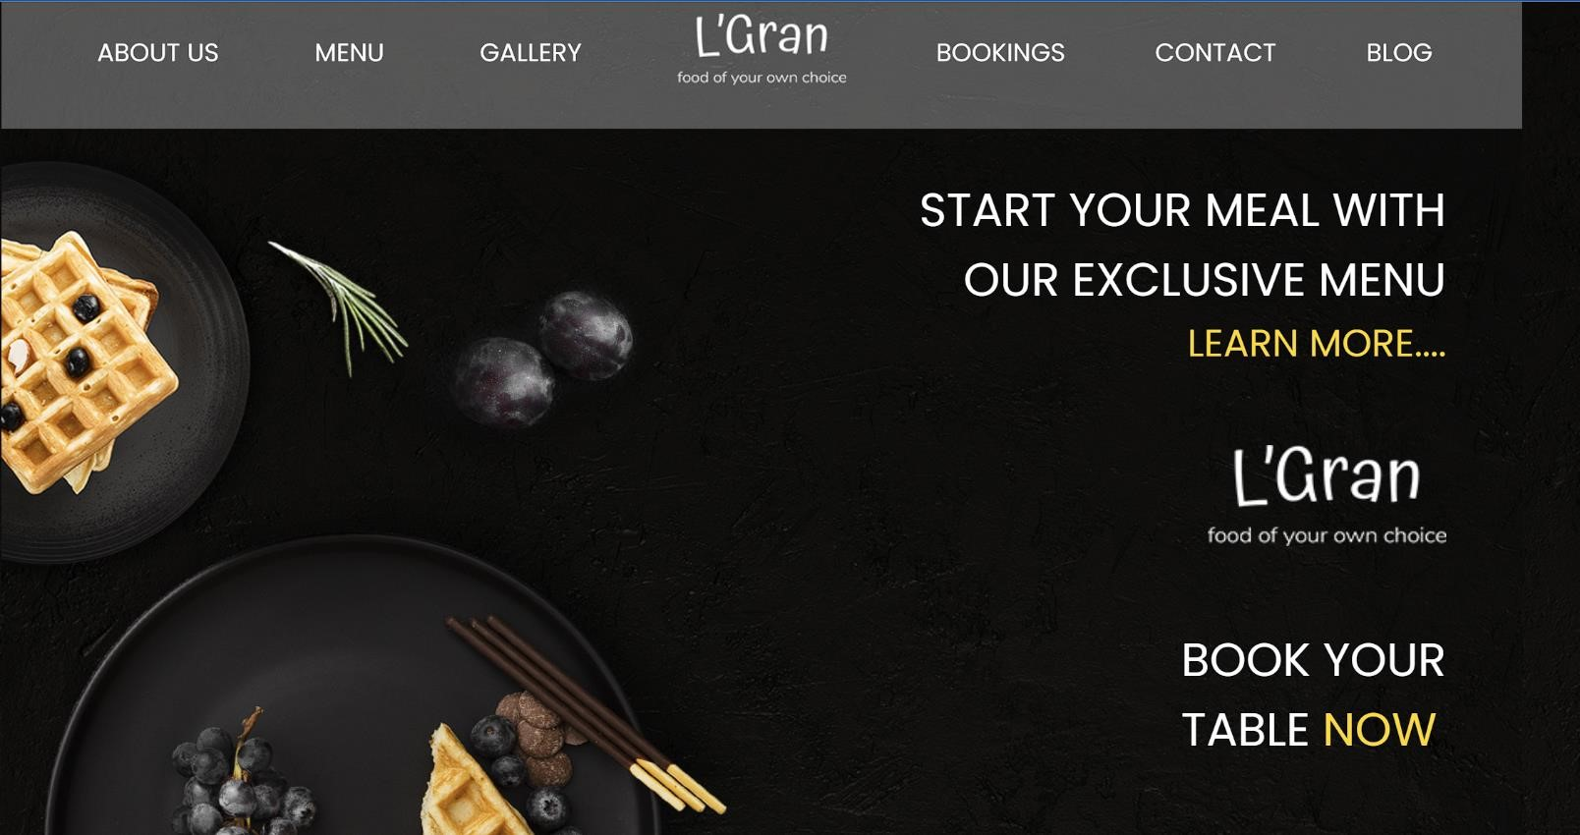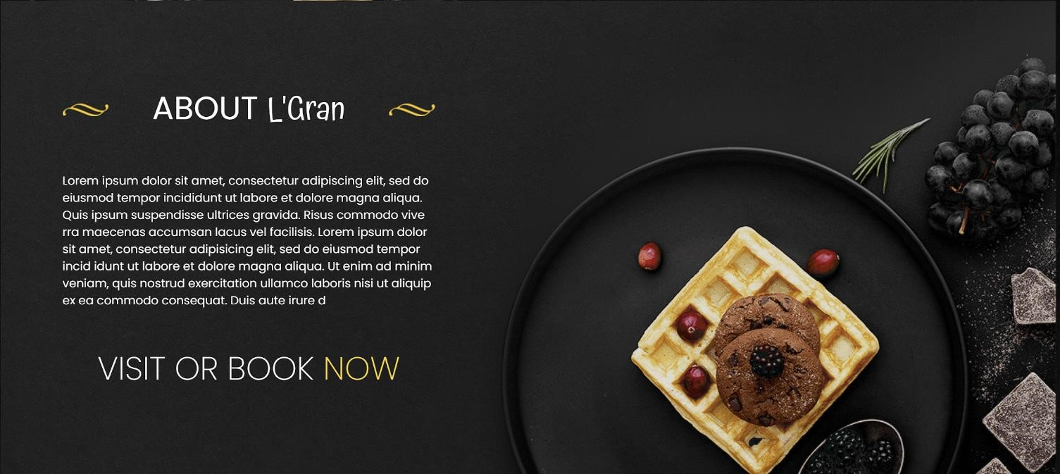RESULT

